What we’ve done:

-Lead by your local PC Jesse Buckingham, your local SNT and colleagues from Matlock and Bakewell attended Ashbourne and the surrounding area to conduct high visibility mobile patrols with the goal of targeting potential drunk drivers in hotspot areas. The team will continue to conduct random regular patrols through these areas to help tackle the issue and will continue to raise awareness throughout the communities.

-Storm Boelo has not deterred your local SNT from conducting their foot patrol duties. With the change in staffing, PC Buckingham and PCSO Coupland have both been out and about, speaking to local businesses and members of the community to engage with the public and listen to any concerns raised.

-Vandalism and Anti-social behaviour in Shawcroft toilets and around Ashbourne has been an ongoing issue for quite some time now. However, with the help of local Schools and community figures, your local Officers have recently been able to Identify several of the groups who are involved in this behaviour. Those named have been spoken to, with the main offenders being issued community service.

November Meeting Dates:
5th 12:30-13:30 Ashbourne Market
8th 10:00-12:00 Ashbourne Remembrance Parade
29th 10:00-11:00 Hulland Ward Farm Shop
21st 11:00-12:00 Doveridge Village Hall (Bike Marking Event)
22nd 10:00-11:00 Brailsford C of E School (Bike Marking Event)
25th 10:00-11:00 Marston Montgomery St Giles' Church community catchup.
26th 10:00-11:00 Ashbourne Market.
27th 10:00-11:00 Tissington Herbert's Fine English Tea Rooms, Community Catch Up.
30th 13:00-14:00 Carsington St Margaret's Church Community Catch Up.

November Newsletter
November 2026
The Good, the Bad & the Neighbourly

What the team has been up to, and what we have planned.

-No insurance? No car! Officers from your local SNT have been patiently waiting for a car being driven with no insurance and was declared SORN (statutory off-road notification) to pop up on our radar. Whilst on foot patrol, Officers managed to spot this vehicle parked up on a public road and seized the vehicle.

-Scouts had a surprise visit from the SNT and our colleagues from the DFRS, where we had a ‘friendly’ competition to see who could get the kids involved more in the topics being discussed. During the talk, we showed off some cool gadgets and toys that would normally only be seen on TV. We brought along thermal imaging cameras, laser speeding cameras, uniforms, riot armour and the big red key for the scouts to have a play with.

-Joint working has been a focus this month with your local SNT making themselves known to the various working partners (such as Platform Housing and Schools) around the area to promote a positive joint working relationship. Several face-to-face meetings have been held with these partners throughout the month to get to know the main problems in the area, and how we can work together to better resolve the issues.

November 2026
November Newsletter

Seized!

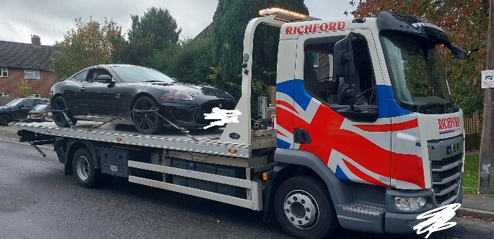



November 2026

What the team has planned:

-As we approach the festive season, Christmas events are springing up all over the Dales area. Your local SNT will be off helping their colleagues throughout the Dales areas with these busy events to have that visible presence.

-This year, your SNT have been given the privilege to attend Ashbourne’s remembrance parade and lay a wreath on behalf of the Derbyshire Constabulary. This is a tremendous honour that we feel privileged to be able to do and we look forward to seeing the amazing turnout from the community.

-Community catchups! With PCSO Coupland getting reacquainted with his community, there will be plenty of meet up opportunities through the months to come. For dates and locations of these meetings, please check the dates and times on this newsletter to stay in the loop.

-Hotspot patrols will continue from your local PC Buckingham and PCSO Coupland to tackle local anti-social behaviour. The team has already been working hard making connections with locals in the community in finding out the areas most affected. In this time, several individuals have been issued warnings for ASB, as well as community service and workshops for those with worse offences.

November Newsletter

