Safer Neighbourhoods

April 2026
Matlock & Tansley.

An Update from March…

What has the team been up to?

-School Visits and Safety Patrols!
Your local PCSO has visited a couple Schools throughout the month to discuss a variety of issues at the School’s request. To raise awareness around knives and to help educate kids around safety with knives, being responsible if they were to ever use them in a controlled environment, and what to do if they ever found one in public. Your SNT Officers have also increased their presence outside of Schools during morning and afternoon shifts to build community relations, and to ‘encourage’ drivers to park safely. During this time, several drivers have been given friendly reminders about the repercussions of parking on the yellow zig-zags outside of School. We have also spotted several drivers who were on their mobile phones whilst driving through these School zones, all of which have been sent tickets for putting the community in harms way!

-New Quarterly Priorities!
Our priorities have been set for the next quarter by our Inspector. The in depth information for this and what was achieved last quarter will be sent via a separate email.

-Library/Community visits
With the increase in staffing, we now have the opportunity to be present in more location for longer periods of time. PCSO Alton has arranged regular meetings with the local Library, where she will be present to offer advice, assurance and resources for anyone with any issues that need raising.

Street meet dates

1st April – Matlock Market Day, 10:00-11:00hrs.

2nd April- Soul Food Café, Church Street, 11:00-12:00hrs

8th April- Matlock Market Day, Hall Leys Park, 13:00-14:00hrs

14TH April- M&S, Bakewell Road, 10:00-10:30hrs

17th April- Tansley Village Hall, 15:30-16:00hrs

26th April- Church in the Peak, Lime Tree Road, 10:00-11:00hrs

29TH April- Matlock Market Day, Hall Leys Park, 10:00-11:00.

Safer Neighbourhoods
Matlock & Tansley.

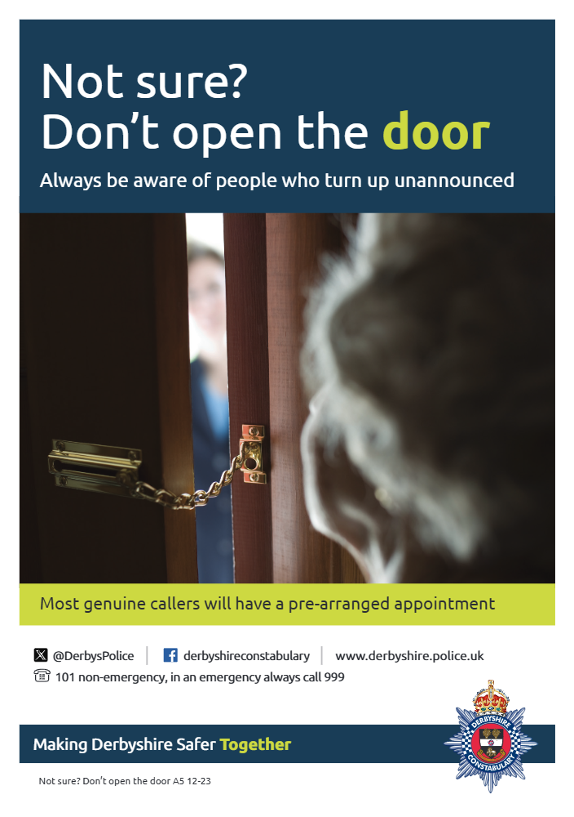

-New PCSO and PC’s (Another one)
We have ANOTHER new PCSO and a couple more PC’s joining the team! We would like to welcome PCSO Hart, PC Buckingham and PC Walker to the team. These Officers will be out and about in the area so please feel free to have a natter with them if you see them!

Want your bike put on the national

The Little Book of Big Scams is an amazing FREE recourse you can grab and view online, full of advice, tips and tricks to help stay safe from scammers. If you, or anyone you know has been a victim of a scammer, or you believe someone could benefit from this, you can find this online by simply typing “The Little Book of Big Scams – 5th Edition” into your internet browser.
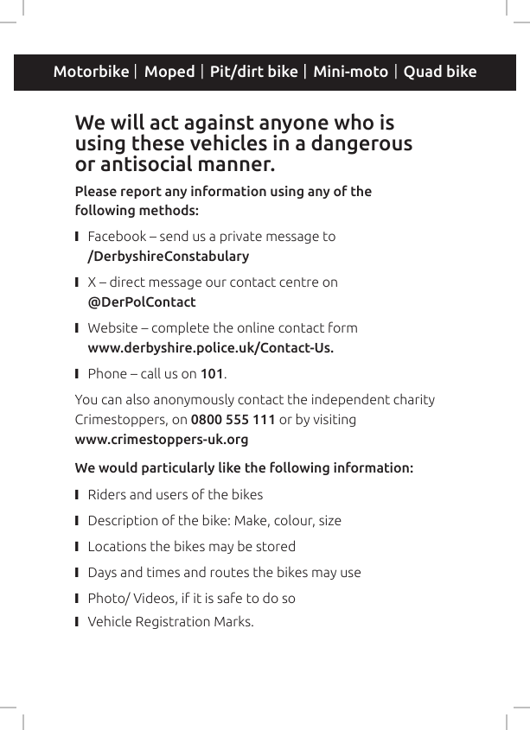

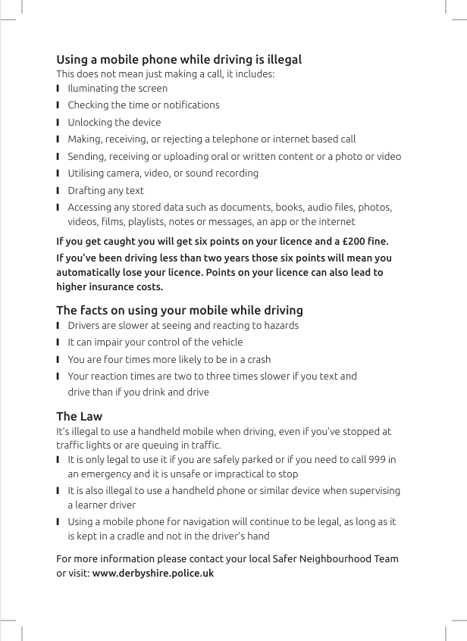

Safer Neighbourhoods
Matlock & Tansley.





