Safer Neighbourhoods
Matlock Bath, Cromford, Wirksworth,
Middleton by Wirksworth & Bonsall August 26
New Priroties for July – September 2026…

July saw a refresh for the next quarter of the year proirites… and an update on what we have done in that last quarter…

This update outlines the progress made on the community priorities set for your area by the Local Policing Inspector John TROUP in collaboration with the Safer Neighbourhood Supervisors, Sgt Chris GRANT and PCSO Supervisor Karl MILLWARD.

Community priorities are reviewed and set on a quarterly basis, guiding the focus of the Safer Neighbourhood Team’s activity, in this update, you’ll find:
- A summary of the previous priorities
- The actions taken and outcomes achieved
- The new priorities for the upcoming quarter
New priorities are determined by analysing local crime trends and incorporating feedback from you, the community, through engagement events, surveys and direct contact.

SNT AREA: Wirksworth, Matlock Bath, Cromford, Middleton by Wirksworth and Bonsall.
The previous priorities were: - Speeding
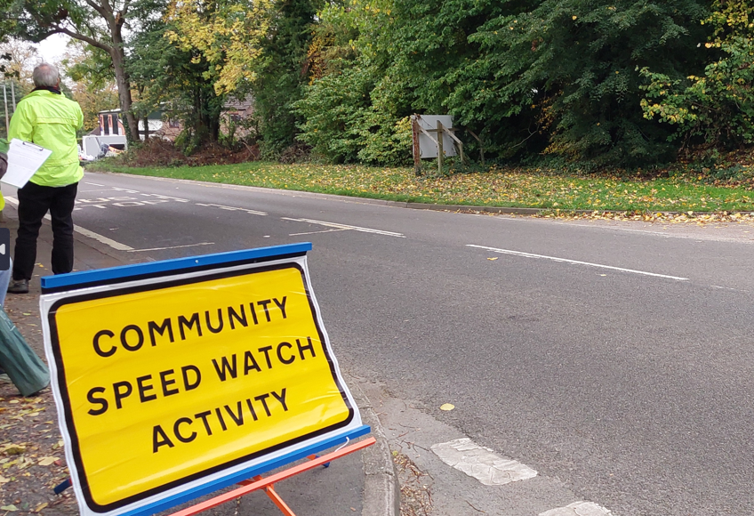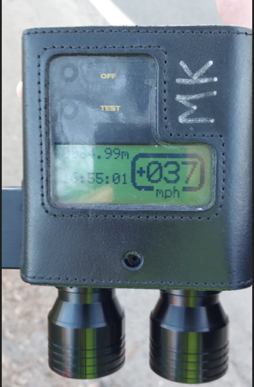

Community Catch-Ups...

Please see further into the newsletter a list of September-December,
Community Catch Ups.

PCSO Hunt will also be popping in as many Community groups as she can throughout the month too! So, you
might see her there!

Can’t make one of our Community
Catch Ups and would like to speak to
us, or arrange a
tool marking visit, please email us via MNT@derbyshire.police.uk and one of the team will be in contact with
you asap.

Safer Neighbourhoods
Matlock Bath, Cromford, Wirksworth,
Middleton by Wirksworth & Bonsall August 26
Action Taken:
In relation to Speeding, we have implemented a Partnership Problem Solving Plan in collaboration with key members of the Community Speed Watches and CREST (Police Speed Enforcement). This plan takes a holistic approach to addressing issues and around Speeding with all partners working towards a shared objective while taking responsibility for their respective areas of focus.

From a policing perspective, we have led on enforcement activity by conducting both high-visibility speed checks in all areas, leading to positive action being taken against those that have chosen to exceed the speed limit.
These outcomes reflect our continued commitment to tackling drug-related crime and maintain community safety through proactive policing.

Outcomes:
• We have seen a decrease in speeding in areas where this has been reported to be an issue.
• Three active Community Speed Watches – Cromford, Middleton by Wirksworth & Wirksworth.

New priorities:
Following this review, the SNT has identified the following priorities for the upcoming quarter:
- Nuisance Parking/Vehicles in Matlock Bath
- Shoplifting in Wirksworth

In relation to the new Priorities, we will:
Suggestions
- Conduct regular high visibility and plains clothes patrols in known hotspot areas for shoplifting.
- Attend local meetings (e.g. Parish council, community forums) to gather feedback and share updates.
- Promote road safety awareness through school visits and youth engagement sessions.
- Take proactive enforcement action against offences such as obstruction and anti-social driving
- Work with Roads Policing Unit for joint operations where necessary
- Collaborate with local councils to identify infrastructure improvements (signage, traffic calming).
- Liaise with Highways and CCTV teams to support evidence gathering and deterrence.
- Share updates and crime prevention advice via Derbyshire Alert and social media
- Publicise successful interventions to reassure the community and encourage reporting.

Safer Neighbourhoods
Matlock Bath, Cromford, Wirksworth,
Middleton by Wirksworth & Bonsall
What we have done in July and August, working in partnership on Nuisance Parking/Vehicles in Matlock Bath…

A working partnership has come together including Police, Derbyshire Dales District Council, Matlock Bath Parish Council, Elected Member of Parliament and their team to discuss issues around the following…

- Parking on the pavements by all vehicles.
- Parking signage throughout the village – includes both yellow/white lines and street signage.
- Parking and/or Police enforcement.
- Road Safety – such as speeding, layout of North & South Parade and volume of traffic that the A6 gets.
We agreed to look at the following potential solutions…
- Use excess pavement on the riverside - create new, additional bike 'cut out' bays to add capacity and loading bay for deliveries.
- Installation of benches planters on the riverside to stop pavement parking, if cut out bays for parking cannot be established.
- Road humps / raised crossings to slow traffic / prevent ASB driving on main A6.
- Extend yellow/white line on pavement to highlight that the double yellow lines extend to the pavement also – to advise that there is no parking on the pavement.
- Electronic car park capacity signs to show capacity at DDDC car parks along the A6.
- Parking Enforcement officers – to look at a different patrol strategy to suit Matlock Bath.

We have patrolled the area and spoke to/advised/used enforcement around the issues mentioned above – it is great to say that 99% of people spoken to has been positive and issues rectified straight away – the other 1% have received fines for parking.

Overall, the main aim of this partnership working is to make Matlock Bath a safer place to visit for all, not to deter anyone visiting. Updates to follow.

Safer Neighbourhoods
Matlock Bath, Cromford, Wirksworth,
Middleton by Wirksworth & Bonsall August 26
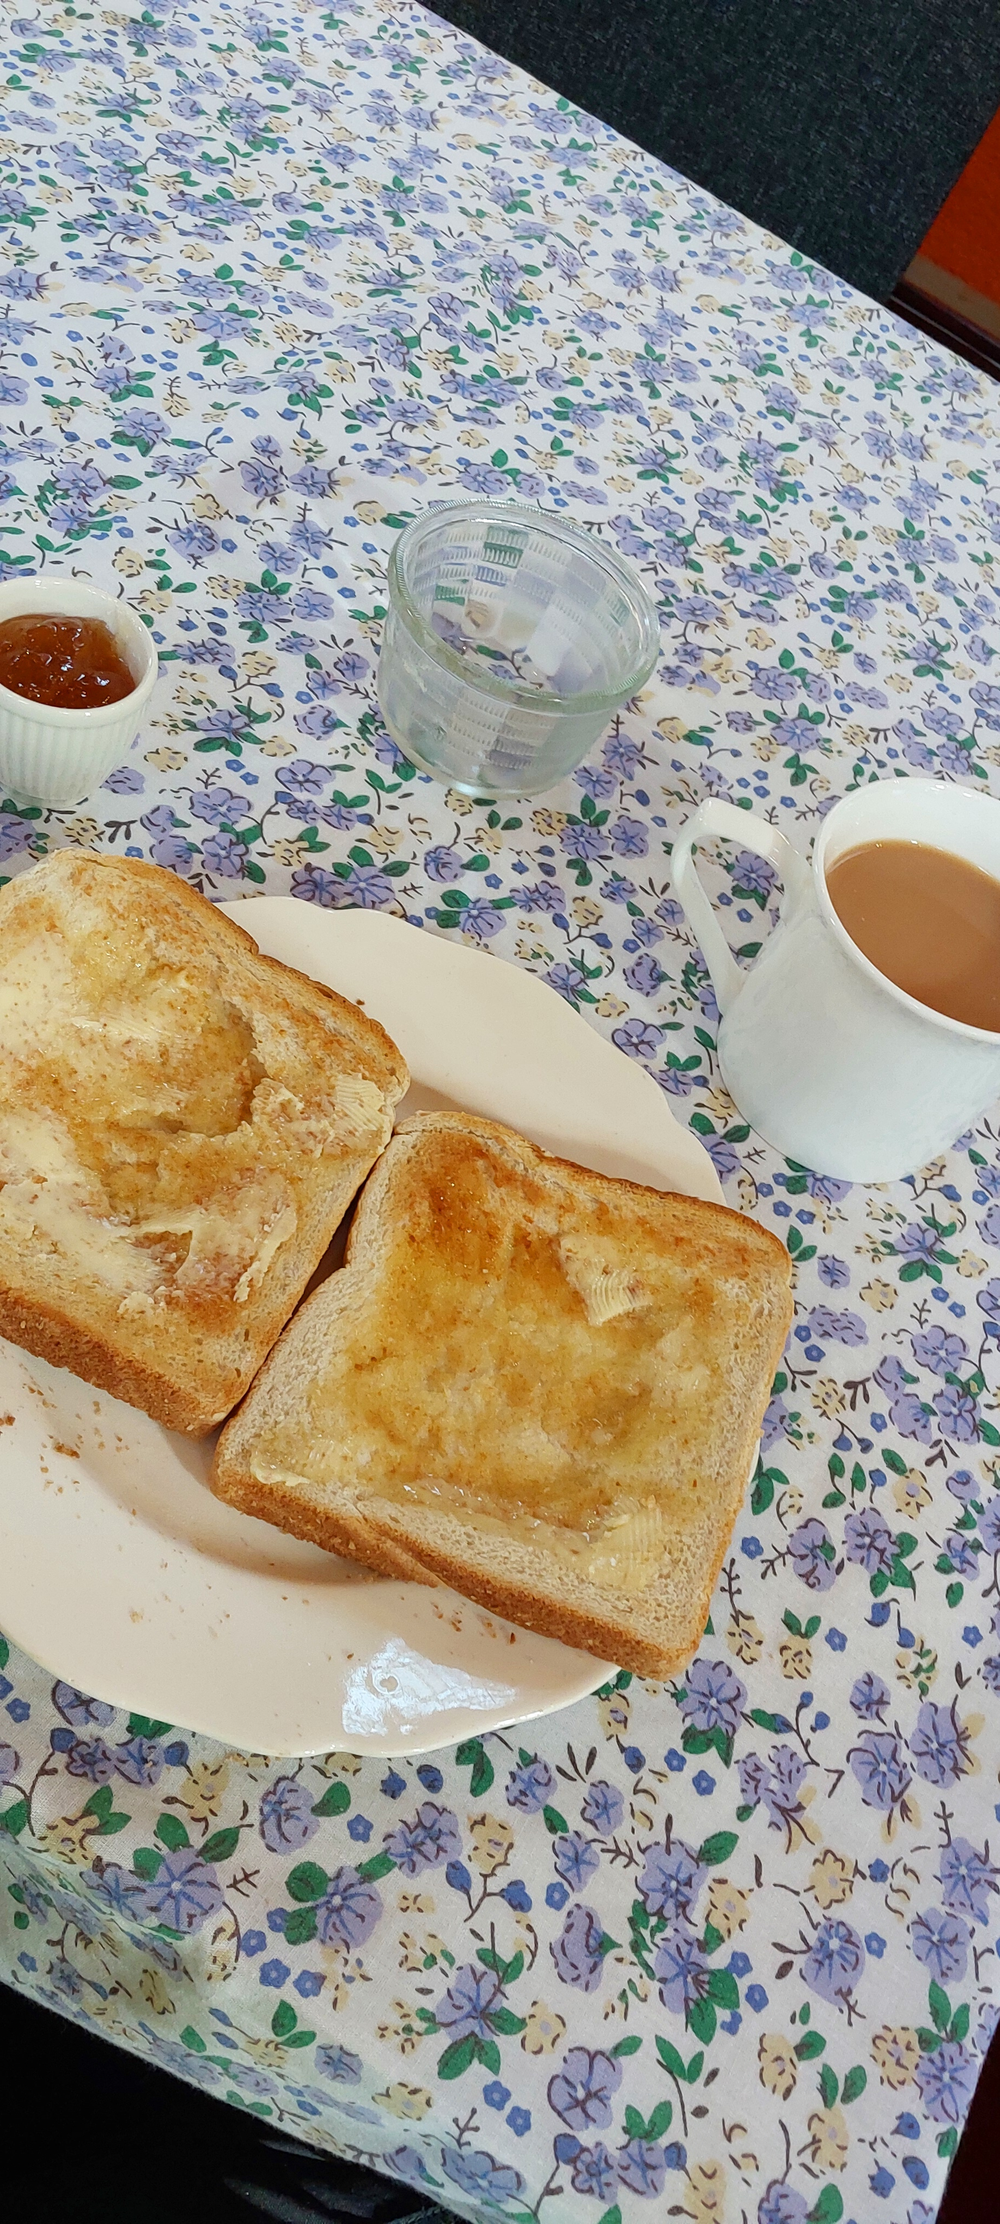
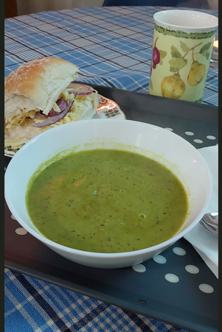
School Talks & Community Groups

The last few months took PCSO Hunt to Matlock Bath Primary and Wirksworth Infants where we discussed Summer Safety. With the pending summer holidays fast approaching, it’s a great way to get those young minds thinking about how to be safe in summer when out and about wherever they choose to go. We discussed not going into delrelict buildings or building sites to being safe in water.

PCSO Hunt also visited Anthony Gell to discuss Anti-Social Behaviour occuring at Stoney Wood (furhter details on this later in the newsletter).

PCSO Hunt has also visited vairous community groups, such as knit & natter, tea & toast, easy meals and catching up with residents at Waltham House. These groups give us the opportunity to discuss issues, concerns and crime prevention. As sometimes residents are hard to reach, or sometimes unsure who to speak too. It is always a great pleasure to help people with such issues etc…

Would you like PCSO Hunt to visit your group? Drop us an email – MNT@derbyshire.police.uk or call 101 and ask to speak to PCSO Hunt, 12900.

Derbyshire Alert & Community Voice…

Have you signed up to our two-way messaging service Derbyshire Alert? This is where you receive messages from your Safer Neighbourhood Team, around prevention advice, appeals, meeting your SNT, and local crime information. This is also where you can request a copy of our Burglary newsletter and Land Rover theft prevention newsletter, for example.

Visit www.derbyshirealert.co.uk to sign up or visit one of our many Community Catch Ups (see first page for info), we hold to sign you up.

There is also the Community Voice, a survey about the area where you live, that gives you the opportunity to tell us about what we should be prioritising. We will be reviewing these next few months, so don’t miss your opportunity to speak up.




Safer Neighbourhoods
Matlock Bath, Cromford, Wirksworth,
Middleton by Wirksworth & Bonsall August 26
ASB in Wirksworth
As the summer holidays are in full swing, it has become apparent that anti-social behaviour has increased, which is quite normal for summer holidays. However, it is not fair to involve or subject members of the community, with such behaviours.
Knock a Door Running:
It has been brought to our attention that there are groups of people - (age range unknown) that are wandering around Wirksworth knocking and kicking on doors, then running off.
Firstly we would like to ask any parents and guardians if you believe that your children could be involved in such behaviour and to any adults thinking that it is ok - to please stop now. We have to consider that we do no know who is behind that door and you may not realise that you could cause criminal damage - resulting in us knocking on your door, if found out.
Secondly, for those that are experiencing these issues to please not answer your door, those causing the issues are wanting a reaction from you and get excited at the thought that you have reacted, resulting in them wanting to do it more - not giving them the time of day will result in them getting bored and will leave you alone.
We will be patrolling more frequently to stop such behaviour and dealing with anyone found to be acting in an anti-social manner accordingly.
Underage drinking – Stoney Wood:
Over the last month or so it has become apparent that students from Anthony Gell, Highfields and QUEGs have formed a chat group on social media to organise parties in Stoney Wood. We understand that there isn’t much for teenagers to do, and it’s great that they have found somewhere to hang out with friends.
However, these gatherings are exceeding 60 teenagers from all areas and are underage drinking. Your Safer Neighbourhood Team, have patrolled the area to confiscate any alcohol for those who are under the age of 18, support any that are under the influence and need to be taken home to parents and working with the schools to engage to put a stop to the underage drinking. Yes, we were all young once have most likely taken part in such activities, but it is the volume of people attending the area and drinking that is worrying us. We have already received information that an ambulance has had to be called due to a teenager falling ill due to drinking alcohol, teenagers are just stumbling around Middleton Road – which in turn this road is/can be dark and a national speed limit zone which could be catastrophic, if anyone was to be hit by a vehicle and fires being lit in the fire pit – at this time no fires should be being lit, due to how dry woodlands are at present.
Our main message is to parents and guardians – please when you are aware that your teenagers are attending Stoney Woods, please ensure that they are not intending to underage drink – as it will be confiscated as well as disposed of at the time and that they act in an appropriate manner when out in the community – as to reduce disruption and ASB in the area. We do not wish to get to the stage that all attending such gatherings, that parents will be asked to collect their teenager right away.

Safer Neighbourhoods
Matlock Bath, Cromford, Wirksworth,
Middleton by Wirksworth & Bonsall August 26
Community Catch Ups – September -December 2026
September –
ND08 – 04/09/26 – United Reform Church, Wirksworth, Tea & Toast – 9:30-11AM
ND08 – 05/09/26 – Wirksworth Famers Market, The Memorial Hall, Wirksworth – 9AM-12PM
ND07 – 05/09/26 – St James Church, Bonsall – 1PM-2PM
ND07 – 06/09/26 – Second Level of Temple Walk Car Park, Matlock Bath – 10-11AM
ND08 – 09/09/26 – Co-Op, Wirksworth – 4-5PM
ND07 – 10/09/26 – St Marks Close, Car Park, Cromford – 4-5PM
ND07 – 14/09/26 - Knit & Natter, The Nelson Pub, Middleton by Wirksworth – 1-3PM
ND08 – 22/09/26 – Wirksworth Market, The Memorial Hall, Wirksworth – 8:30AM-12PM
October –
ND08 – 02/10/26 – United Reform Church, Wirksworth, Tea & Toast – 9:30-11AM
ND08 – 03/10/26 – Wirksworth Famers Market, The Memorial Hall, Wirksworth – 9AM-12PM
ND07 – 03/10/26 – St James Church, Bonsall – 1PM-2PM
ND07 – 03/10/26 – Second Level of Temple Walk Car Park, Matlock Bath – 10-11AM
ND08 – 04/10/26 – Wizarding Day, Wirksworth Fire Station, 11AM-3PM
ND07 – 12/10/26 - Knit & Natter, The Nelson Pub, Middleton by Wirksworth – 1-3PM
ND08 – 20/10/26 – Wirksworth Market, The Memorial Hall, Wirksworth – 8:30AM-12PM
ND07 – 31/10/26 – St James Church, Bonsall – 12PM-1PM
November -
ND08 – 04/11/26 – Co-Op, Wirksworth – 4-5PM
ND07 – 05/11/26 – St Marks Close, Car Park, Cromford – 4-5PM
ND08 – 06/11/26 – United Reform Church, Wirksworth, Tea & Toast – 9:30-11AM
ND07 – 23/11/26 - Knit & Natter, The Nelson Pub, Middleton by Wirksworth – 1-3PM
ND07 – 28/11/26 – St James Church, Bonsall – 1PM-2PM
ND07 – 29/11/26 – Second Level of Temple Walk Car Park, Matlock Bath – 10-11AM
December –
ND08 – 02/12/26 – Co-Op, Wirksworth – 4-5PM
ND07 – 03/12/26 – St Marks Close, Car Park, Cromford – 4-5PM
ND08 – 08/12/26 – Knit & Natter, Library, Wirksworth – 2-4PM
ND08 – 15/12/26 – Wirksworth Market, The Memorial Hall, Wirksworth – 8:30AM-12PM
ND07 – 19/12/26 – St James Church, Bonsall – 1:30PM-2:30PM
ND07 – 20/12/26 – Second Level of Temple Walk Car Park, Matlock Bath – 2:30-3:30PM

